

**Faculty of Arts and Sciences**

**Department of Computer Science**

CMPS 253 – Software Engineering

Spring 2015 Class Project

Instructor: Mahmoud Bdeir



**Final Report**

|  |  |
| --- | --- |
| Class Section | 2 |
| Project Name | Educo |
| Team Name | Educo Team |
| Team Members | Samer AL Masri - Adnan Utayim – Sarah Tabet |

**Table of Content**

1. Workload balance 2

2. Requirements: 2

2.1. Release 1 2

2.2. Release 2 3

2.3. Release 3 3

2.4. Release 4 4

2.5. Release 5 4

3. Comments: 4

4. What is not implemented: 5

5. Known issues: 5

6. Difficulties encountered: 6

7. Lessons learned: 6

8. How to improve the application in the next releases: 6

9. Other artifacts deemed relevant: 7

# Workload balance

Check Educo’s Software Project Management Plan section 2.4 Project Responsibilities (page 8).

# Requirements

## Release 1

|  |  |  |
| --- | --- | --- |
| **As a(n)** | **I would like to** | **Status** |
| General User | Apply for a role | **Complete** |
| General User | Enter my schedule | **Complete** |
| General User | Check my schedule | **Complete** |
| General User | Have my schedule be automatically updated when I have an appointment | **Complete** |
| General User | Delete my account | **Incomplete** |
| Admin | Only allow currently registered students to use the software | **Complete** |
| Admin | Have my tutors interviewed | **Incomplete** |
| Admin | See a list of interviewer applicants | **Incomplete** |
| Admin | Accept/reject an interviewer applicant | **Incomplete** |
| Admin | Get the feedback on a tutor from an interviewer | **Complete** |
| Admin | Accept/reject an interviewed tutor applicant | **Complete** |
| Admin | Have a database of all the courses, tutors and students | **Complete** |
| Admin | Accept/reject a new course offered by a tutor (for discouraging spam) | **Complete** |
| Admin | See a list of my tasks | **Complete** |
| Admin | Keep the applicants’ contact information | **Complete** |
| Admin | Keep a log of all the appointments scheduled through my software | **Complete** |
| Interviewer | Schedule an interview | **Incomplete** |
| Interviewer | See a list of my tasks | **Complete** |
| Interviewer | See a list of tutor applicants | **Incomplete** |
| Interviewer | Open the file of a tutor applicant | **Incomplete** |
| Interviewer | Write feedback on an applicant | **Complete** |
| Tutor | Schedule an interview | **Complete** |
| Tutor | Sign up as a tutor | **Complete** |
| Tutor | Keep my schedule | **Complete** |
| Tutor | Modify my schedule | **Complete** |
| Tutor | Teach new courses | **Complete** |
| Tutor | Decide my price per hour | **Complete** |
| Tutor | Keep track of my appointments and students | **Complete** |
| Tutor | Cancel an appointment | **Incomplete** |
| Student | Sign in as a student | **Complete** |
| Student | Search for a tutor by course | **Complete** |
| Student | Search for a tutor by name | **Complete** |
| Student | Know the tutor’s qualifications and background as a tutor | **Incomplete** |
| Student | Know the tutor’s teaching method | **Incomplete** |
| Student | Know the price demanded by each tutor | **Complete** |
| Student | Pick an appointment | **Complete** |
| Student | Have my activity remain private from other students (excluding admins) | **Complete** |
| Student | Cancel an appointment | **Complete** |
| Student | Have the contact information of my tutor | **Complete** |
| Student | Rate my tutor | **Incomplete** |

## Release 2

|  |  |  |
| --- | --- | --- |
| **As a(n)** | **I would like to** | **Status** |
| General User | Have multiple attempts to enter the right password | **Incomplete** |
| General User | Reset my password in case forgotten | **Incomplete** |
| General User | Have a newsfeed that keeps me updated of what’s new in the application |  |
| Admin | Promote a user into an admin | **Incomplete** |
| Admin | Have my tutors trained by other tutors | **Incomplete** |
| Admin | Allow merged accounts (student and tutor) | **Incomplete** |
| Admin | Promote a user into an admin | **Incomplete** |
| Interviewer | Have the minimum requirements for an applicant to be accepted | **Incomplete** |
| Tutor | Be able to have a student account as well | **Incomplete** |
| Tutor | Stay close to campus | **Complete** |
| Tutor | Teach a limited amount of students/hour | **Complete** |
| Tutor | Receive a certification of my work | **Incomplete** |
| Student | Be able to sign up as a tutor as well | **Incomplete** |
| Student | Be updated on any change in the schedule | **Incomplete** |

## Release 3

|  |  |  |
| --- | --- | --- |
| **As a(n)** | **I would like to** | **Status** |
| Admin | Have statistics about my tutors and students (age-universities…) | **Incomplete** |
| Tutor | Be notified when contacted | **Incomplete** |
| Tutor | Be notified at least one hour before the cancellation of an appointment | **Incomplete** |
| Tutor | Be in a community of tutors and not only binary relationships | **Incomplete** |
| Tutor | Communicate with my students | **Incomplete** |
| Tutor | Share files with my students through the software | **Incomplete** |
| Student | Be notified at least one hour before the cancellation of an appointment | **Incomplete** |
| Student | Easily contact the tutor through the software | **Incomplete** |

## Release 4

|  |  |  |
| --- | --- | --- |
| **As a(n)** | **I would like to** | **Status** |
| Interviewer | Have a list of available times that concord to both my schedule and the applicant’s | **Incomplete** |
| Tutor | Have the software recommend me available students based on my schedule | **Incomplete** |
| Tutor | Recommend an available substitute in case of cancellation | **Incomplete** |
| Student | Be able to substitute my tutor for another in case of cancellation | **Incomplete** |
| Student | Know what tutor is currently available | **Incomplete** |

## Release 5

|  |  |  |
| --- | --- | --- |
| **As a(n)** | **I would like to** | **Status** |
| Admin | Keep track of my user-related geographical data on a map | **Incomplete** |
| Admin | Allow students from other universities | **Incomplete** |
| Student | Know the location of my tutor | **Incomplete** |

# Comments

* Following a previous argument, in further releases the Educo tutor-finder webpage will be integrated with the book-exchange service BOOX that also targets students of the American University of Beirut.
* Due to time shortage, the buttons of the course and tutor profile were not completely adapted esthetically to the website.
* The implementation of the feature that allows the user to upload a picture to his profile was not finalized and tested and was therefore removed.
* The application’s interviewer is assumed to be already employed therefore no need for the sign up as an interviewer feature and everything that goes with it.

# What is not implemented

The limited time that the Educo team had to implement its application didn’t allow for every feature wanted in release one to be completed:

* The Appointments feature of the homepage that allows a user to know what are his current appointments and details about them was not yet implemented.
* Subsequent to the assumption that the application already has an interviewer for the current release all the features related to the creation of an interviewer account (signing up as an interviewer, see a list of interviewer applicants, accept or reject an interviewer…) were not yet implemented.
* Following the upload comment in Section 3 of this document a tutor cannot yet upload a CV for the interviewer to read.
* A student cannot know the tutor’s teaching method because users are not yet able to write their own description in their profile.
* A user cannot yet delete his account.

# Known issues

No code is big free. Here are a few bugs known about that will be fixed by the time release 2 comes:

* The tutor cannot cancel an appointment booked by a student.
* The logout is not fully functional: it doesn’t kill the session therefore if we click back we are directed again to the user’s account.
* If we log in as a tutor and enter our profile, the magnifier in the search bar that allows to either search by course or by tutor disappears.
* When an interviewer writes feedback on an applicant the feedback doesn’t show in the admin’s account.
* In the schedule, the days’ cells are not of the same length.
* A user can sign up without having entered all the required information.
* When a user clicks on sign up, the sign up succeeds but the user’s email and telephone number stay visible in the signup text boxes (as if the page doesn’t refresh).

# Difficulties encountered

The Educo team is a devoted optimistic team that thrives to deliver the highest quality possible and provide its customers with a pleasant user experience. However the path to reach our desired goal was not without obstacles and we faced numerous constraints. For the list of difficulties check Educo’s Software Project Management Plan Section 3.3 Assumptions, Dependencies, and Constraints (page 9).

# Lessons learned

This project taught us mainly the process of developing a product and the way and importance of workings in a self-organized team. We learned that coding and implementation are not what makes a project successful, but rather the way it was organized, developed and presented. The team learned to accomplish every step that makes software engineering a process and not just coding, being: writing proper complete requirements, planning future releases, organizing sprints and their estimations, designing a database and writing test cases. The whole process, while seemingly time-consuming at first, actually ended up quickening our implementation by having every requirement recorded clearly and everything designed and present, recorded and being kept track of in a “pretty picture” just waiting to be filled in the code. Thus, we learned to organize our work to be more productive in a faster way and with better quality assurance.

# How to improve the application in the next releases

The website will be improved in the next releases according to the predicted requirements for each release describes in section 2 of this report. However, not only shall the application be perfected, our performance should be updated as well. In the next releases we should focus more on the business value of the project and understand what's most important to the client’s business, so that we can focus on these requirements and deliver features in the most valuable order. We got so enthusiastic in making the best tutor-finder website that we started implementing unnecessary features and got drifted away from the main point, we ended up with a pile of half-baked pies instead of having one proper pie. Also, our weekly meetings should be conducted more effectively. Though we met at least once weekly we should have used our time in a more productive way. In order to achieve the best website, we must thrive to reach the best of ourselves.

# Other artifacts deemed relevant

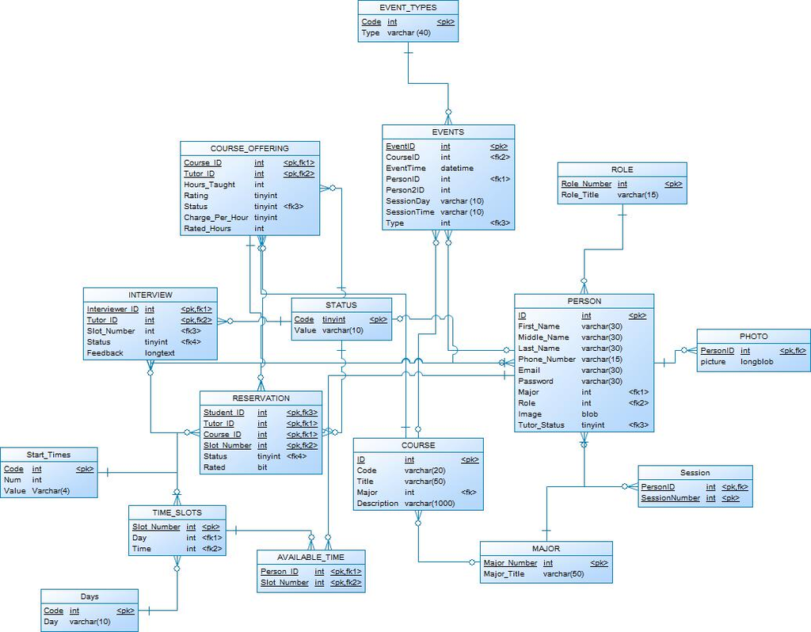Below is a screenshot of our database design.